**BUG TEMPLATE: SPICY**

**BUG ID**: 01

**BUG NAME**: Search bar is not working on home page.

**ASSIGNEE**: New assigned

**STATE**: New

**DESCRIPTION**: 1. Open spicy application.

2. In home page, select HYSAS restaurant.

3.Please refer the screenshot

**OBSERVATION**: Here search bar is not working.

**EXPECTED**: Search bar should work.

**PRIORITY**: High

**SEVERITY**: Low

**ATTACHMENT**:

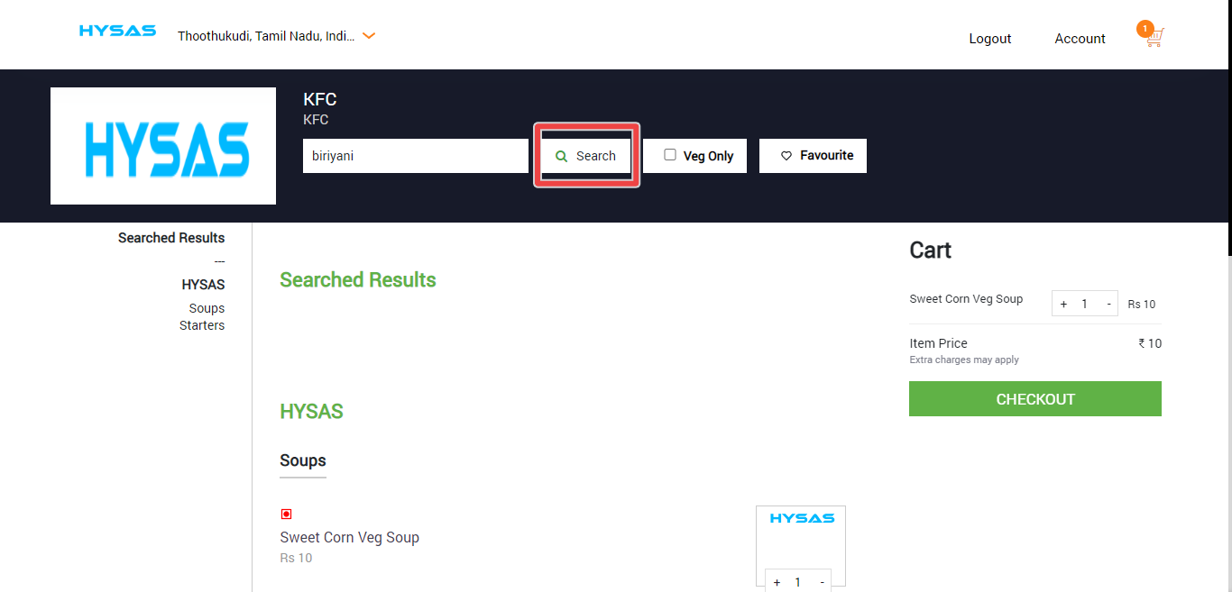

**BUG ID**: 02

**BUG NAME**: Veg only is not working on home page.

**ASSIGNEE**: New assigned

**STATE**: New

**DESCRIPTION**: 1. Open spicy application.

2. In home page, select HYSAS restaurant.

3.Please refer the screenshot

**OBSERVATION**: Here Veg only is not working.

**EXPECTED**: Veg only should work.

**PRIORITY**: High

**SEVERITY**: Low

**ATTACHMENT**:

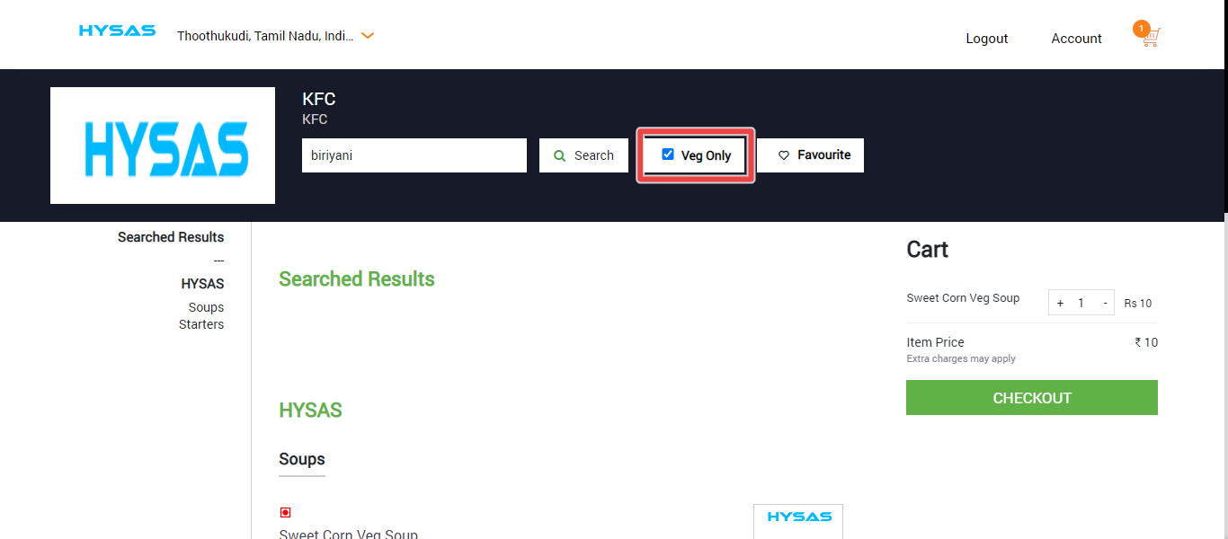

**BUG ID**: 03

**BUG NAME**: Favourite is not working on home page.

**ASSIGNEE**: New assigned

**STATE**: New

**DESCRIPTION**: 1. Open spicy application.

2. In home page, select HYSAS restaurant.

3.Please refer the screenshot

**OBSERVATION**: Here Favourite is not working.

**EXPECTED**: Favourite should work.

**PRIORITY**: High

**SEVERITY**: Low

**ATTACHMENT**:

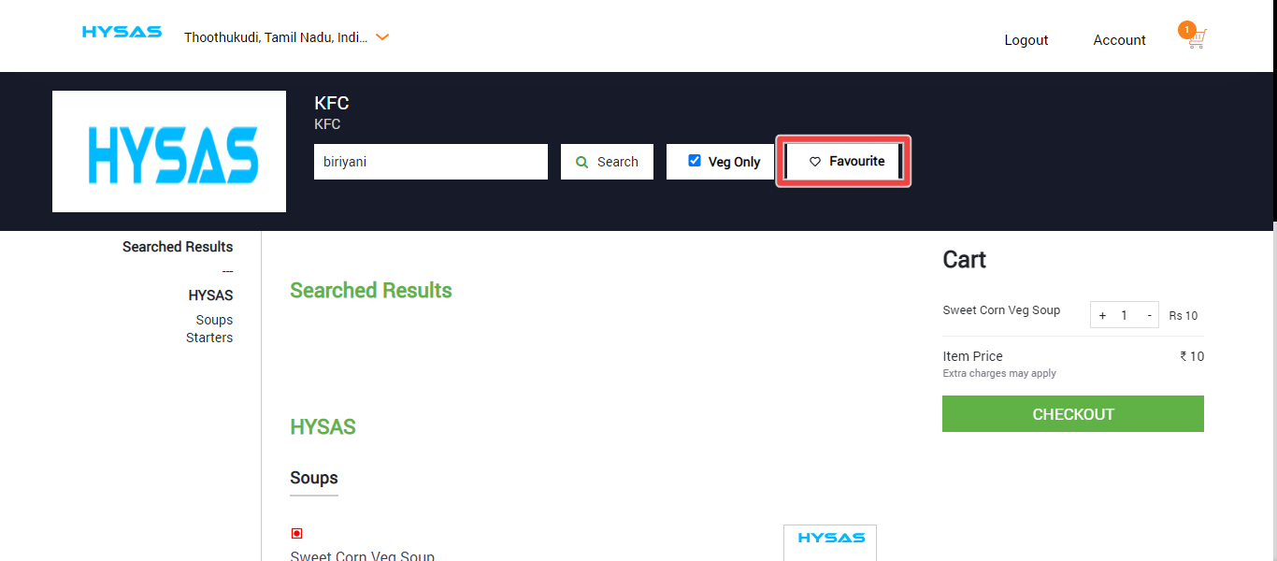

**BUG ID**: 04

**BUG NAME**: Sweat corn veg soup recipe image can,t be displayed.

**ASSIGNEE**: New assigned

**STATE**: New

**DESCRIPTION**: 1. Open spicy application.

2. In home page, select HYSAS restaurant on food lists.

3.Please refer the screenshot

**OBSERVATION**: Here Sweat corn veg soup recipe image can,t be displayed.

**EXPECTED**: Sweat corn veg soup recipe image should be displayed.

**PRIORITY**: Low

**SEVERITY**: Low

**ATTACHMENT**:

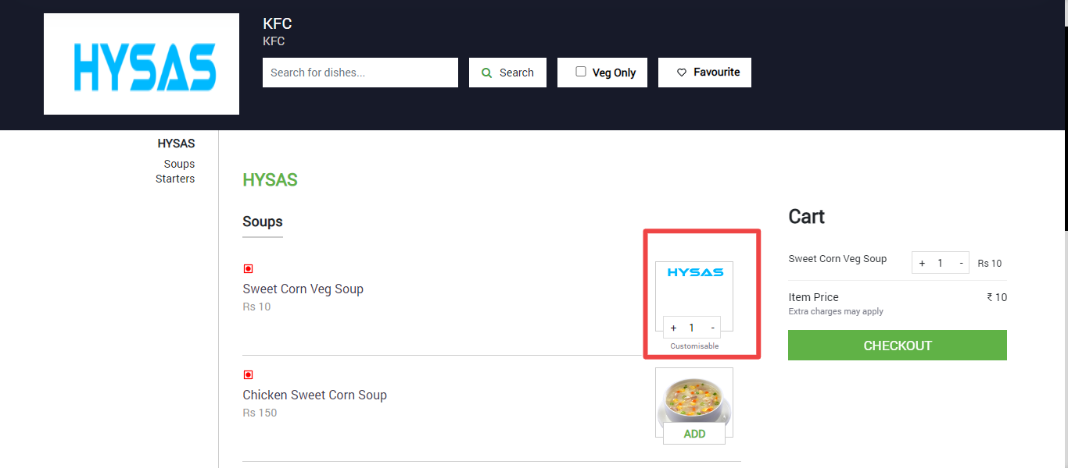

**BUG ID**: 05

**BUG NAME**: Social media icons can’t be working.

**ASSIGNEE**: New assigned

**STATE**: New

**DESCRIPTION**: 1. Open spicy application.

2. In home page, select account.

3. In account page scroll down.

4.Please refer the screenshot

**OBSERVATION**: Social media icons can’t be working, Click that icons return again home page of spicy application.

**EXPECTED**: Social media icons can be working

**PRIORITY**: High

**SEVERITY**: Low

**ATTACHMENT**:

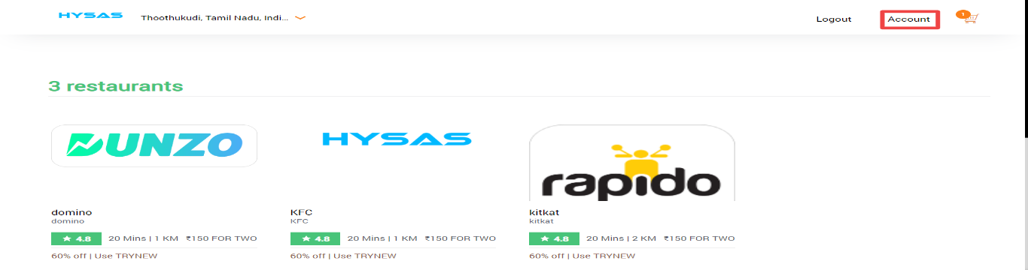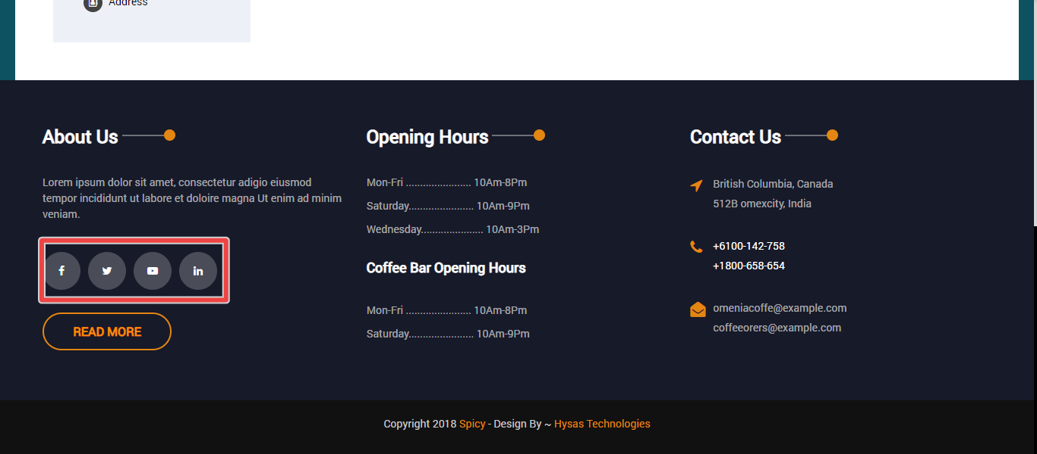

**BUG ID**: 06

**BUG NAME**: Read more button can’t be working.

**ASSIGNEE**: New assigned

**STATE**: New

**DESCRIPTION**: 1. Open spicy application.

2. In home page, select account.

3. In account page scroll down.

4.Please refer the screenshot

**OBSERVATION**: Read more button can’t be working, Click that icons return again home page of spicy application.

**EXPECTED**: Read more button can be working

**PRIORITY**: High

**SEVERITY**: Low

**ATTACHMENT**:

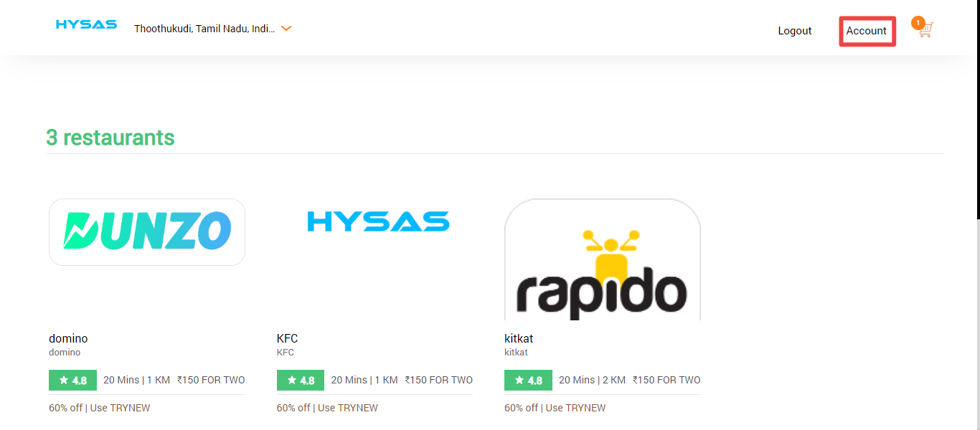

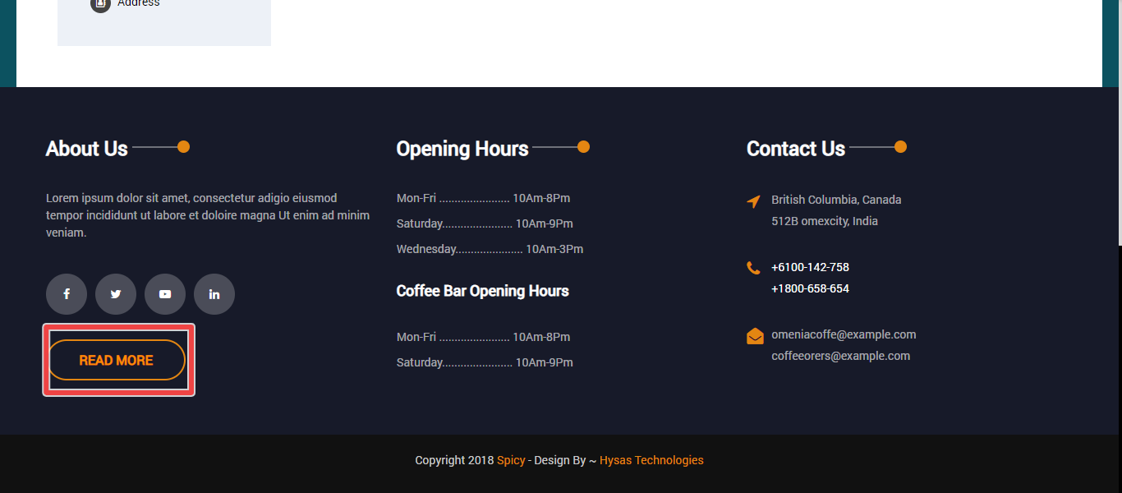

**BUG ID**: 06

**BUG NAME**: Mail id can’t be working.

**ASSIGNEE**: New assigned

**STATE**: New

**DESCRIPTION**: 1. Open spicy application.

2. In home page, select account.

3. In account page scroll down.

4.Please refer the screenshot

**OBSERVATION**: Mail id can’t be working, Click that icons return again home page of spicy application.

**EXPECTED**: Mail id button can be working

**PRIORITY**: High

**SEVERITY**: Low

**ATTACHMENT**:



